BA & Innovation Document for:

Department of Information Systems

INF4027W 2021

Prepared by Team Waffle (Team 11)

**Plagiarism declaration:**

I know that plagiarism is wrong. Plagiarism is to use another’s work and pretend that it is one’s own. I have used the APA 7th convention for citation and referencing. Each contribution to, and quotation in, this proposal from the work(s) of other people has been attributed and has been cited and referenced. This document is my own work. I have not allowed, and will not allow, anyone to copy my work with the intention of passing it off as his or her own work. I acknowledge that copying someone else’s assignment or essay, or part of it, is wrong, and declare that this is my own work. I have not falsified or manufactured any data and declare that all data was ethically collected.

|  |  |  |  |
| --- | --- | --- | --- |
|  |  |  |  |
| Matete Kopano Lebakeng | **Kimberley**  **Mugadza** | **Khanya**  **Ngxabani** | **Maphoro**  **Ramotebele** |

Table of Contents

Table of Figures 4

1. Executive Summary 5

2. Introduction 6

3. Background 6

3.1. Business Background 6

3.2. Project Background 6

3.2.1. Machine Learning 7

3.2.2. Problem Statement 7

3.3. System Objectives 8

3.4. Critical Assumptions, Constraints and Exclusions 8

4. Processes 10

4.1. Current process 10

4.1.1. AS-IS Product Maintenance & Stock Prediction Process 10

4.2. Proposed process 12

4.2.1. TO-BE Product Maintenance & Stock Prediction Process 12

￼

5. Value Added 14

5.1. Business value added 14

6. Challenges 15

7. New Technologies 16

7.1. ML.NET 16

7.2. Azure DevOps and Git 17

8. New Way of doing things 19

8.1. Scrum Methodology 19

8.2. Remote Learning 19

9. Technical challenges 20

10. Application Architecture 21

10.1. Migration process: 22

11. System Scope 23

12. ER Diagram 24

13. Class Diagram 26

14. Conclusion 27

15. References 28

# **Table of Figures**

Figure 1: As-Is Product Maintenance & Stock Prediction BPMN Diagram 14

Figure 2: To-Be Product Maintenance & Stock Prediction BPMN Diagram 17

Figure 3: Figure 3: To-Be Product Maintenance & Stock Prediction Activity Diagram 18

Figure 4: ML.NET 22

Figure 5: Azure DevOps and Git 23

Figure 6: Azure DevOps Application Development WorkFlow 24

Figure 7: Azure DevOps Application Development WorkFlow – with Machine Learning Model Lifecycle 25

Figure 8: Application Architecture 30

Figure 9: Migration Process 31

Figure 10: MSP Package Diagram 34

Figure 11: MSP ERD Diagram for User Relationships 36

Figure 12: MSP ERD Diagram for Dataset entities 37

Figure 13: MSP Class Diagram 38

# 1. Executive Summary

Coge3nt is a private company that is currently the only company in Africa that offers pure intelligent automation services (Cog3nt.com, n.d.). The company specialises in providing businesses with automotive solutions to their problems and has since become known in the Information Technology (IT) industry for is distinctive “automate first approach” (Cog3nt, n.d ). Research conducted by Cog3nt found that store owners ranging from spaza shops, quick shops, tuckshops, and local stores have limited storage and floor space to keep their inventory. Research conducted by Goyal (2020) also found that most of these businesses have their processes like stock taking and managing sales records done manually.

This problem led Cog3nt to derive a blueprint for a solution that could fulfil the following requirements:

1. A web-based application that allows users to manage their products and store their information in a central database.
2. An application that uses an adaptive stock prediction algorithm that will use and analyse data from historic sales records and stock orders to predict optimum quantities of stock required to maximise revenues.
3. Visualise this data graphically using a dashboard or any other suitable method.

This blueprint is known as the Product Maintenance and Stock Prediction System (MSP). The MSP will fall under one of Cog3nt’s product categories called Retialyx. The MSP will use Machine Learning to help store owners plan their stock orders and manage their storage space to optimum levels. This will be achieved through a stock prediction algorithm that will use historic data and sales records to predict what quantities of certain items need to be on hand for x number of days. In other words, when user select a product from the PSP product catalogue, the system should show them how much of that item they should order based on past sales and consumer spending patterns. This will have several benefits for store owners which include:

* **More Accurate Stock Prediction:** Having a manual stock management system means that stores like Marcels must check if they need to update their every day or week.
* **Saves Time**: The MSP will help to reduce the workload on staff while saving them time because it will perform the prediction part of the process on their behalf. This will also improve business productivity and operative efficiency.
* **Centralised Storage Space:** The MSP will also give store owners a platform to manage their store information relating to their products and where relevant, their suppliers. This information will be stored on a local database.
* **Less Wastage:** The use of the MSP can help reduce the number of items that are wasted even if it is inevitable for some items to still be wasted.
* **Optimised Sales:** The use of the MSP will help store owners optimise their sales which will result in less wastage of stock. Store owners have limited storage and floor space to keep their inventory so they must turn over stock as often as possible to keep up with consumer demand.
* **Optimise Available Resources:** If sales are optimised and wastage of stock is reduced, business profits/ revenues will be higher.

Cog3nt will also realise the following benefits:

* Cog3nt will expand their product line which will bring the company closer to achieving its goal of providing businesses with automotive solutions to their problems.
* Cog3nt will also benefit from making a positive contribution to its industry by helping its clients make certain aspects of their businesses better.

The technologies that will be used to implement this solution include Microsoft (MS) Visual Studio where the system will be coded using ASP.NET Core., Azure Devops and the ML.NET library for machine learning. The system will be coded by Team Waffle (Team 11) from the University of Cape Town under the Supervision of Nkosana Guga from Cog3nt.

# 2. Introduction

The product maintenance and stock prediction system (MSP) is a web-based application that manages products using CRUD (Create, Read/View, Edit and Delete) functionalities. These functionalities will allow users to manage and store product records for their stores using an online platform. The second aspect of this system involves using machine learning to predict the optimum quantity of stock that store owners should order. This project is in collaboration with Cog3nt and Team Waffle as part of a Systems Development Honours Project.

This document will give an in-depth analysis into this project and its requirements. We will start by first giving a background to Cog3nt (our sponsor) and the project. This will be done by defining and explaining key terms related to this project such as Machine Learning, providing a brief problem statement and a proposed solution. This document is also split into two main sections. Part one focuses on the business analysis and part two focuses on the innovations of this project.

# 3. Background

## 3.1. Business Background

Coge3nt is a private company that is currently the only company in Africa that offers pure intelligent automation services (Cog3nt.com, n.d.). Intelligent Automation (IA) is defined as the process of using a combination of robotic process automation and artificial intelligence (AI) technologies to improve business processes (Automation Anywhere, n.d.). The company specialises in providing businesses with automotive solutions to their problems and has since become known in the Information Technology (IT) industry for is distinctive “automate first approach.”

In contrast to traditional automation methods which rely on explicit instructions and data inputs, IA processes improve on their own over time. The IA begins with identifying the process where AI tools will be used to analyse the current tasks and patterns in a process. When an IA project is finished, the goal is to have a system that can adjust itself to different circumstances on its own with as little human intervention as possible. This is made possible using AI machine learning (Automation Anywhere, n.d.). Our project will follow this approach in that we will be creating a Product Maintenance and Stock Prediction system that uses AI to automate and improve businesses processes. This project deliverable will, therefore, serve as the initial stage towards an ongoing IA process for stock prediction and management.

## 3.2. Project Background

Research conducted by Cog3nt found that store owners ranging from spaza shops, quick shops, tuckshops, and local stores have limited storage and floor space to keep their inventory. Research conducted by Goyal (2020) also found that most of these businesses have their processes like stock taking and managing sales records done manually. Cog3nt specialises in helping businesses improve their operative efficiency by automating their current processes with Artificial Intelligence (AI). The MSP will fall under one of Cog3nt’s product categories called Retialyx. Cog3nt aims to help retail businesses improve their processes through **intelligent automation** by integrating **artificial intelligence** into their solutions with this product line. The type of artificial intelligence that will be used for this project is Machine Learning.

### 3.2.1. Machine Learning

Machine Learning (ML) is defined as the use and development of computer systems that can learn and adapt to scenarios without receiving explicit instructions (Oxford Learner’s Dictionaries, n.d.). ML is a type of artificial intelligence where computers use large volumes of data to learn how to do tasks. In other words, the use of ML helps computing systems become faster and more accurate. This is because ML-based systems are designed to learn and adapt to new information just like humans would (Oxford Learner’s Dictionary, n.d.).

The MSP will use ML to help store owners plan their stock orders and manage their storage space to optimum levels. This will be achieved through a stock prediction algorithm that will use historic data and sales records to predict what quantities of certain items need to be on hand for x number of days. In other words, when user select a product from the PSP product catalogue, the system should show them how much of that item they should order based on past sales and consumer spending patterns. This will have several benefits for store owners which will be discussed in detail in the Business Analysis (Part One).

### 3.2.2. Problem Statement

Inventory is defined as the stock of raw materials, semi-finished products, and finished goods that a company has on hand to fulfil its organizational requirements (Madhuri et al., 2020). It is a significant investment and a source of waste that must be closely monitored. Inventory is also characterized as a business's stock of products that is kept on hand in anticipation of potential demand or sales (Praveen et al., 2020). Managing their stock or inventory is an important process for businesses, especially for small retail stores. A business’s main objective is to make a profit, and this is achieved by maximising sales. One of the biggest cost's businesses incur is related to stock and inventory. Businesses, therefore, need to have good stock planning and management systems because this impacts their revenues directly.

Small store owners face both internal and external risks when running their businesses. The demand for goods is determined by a variety of factors such as the business's competitiveness, the day of the week (the demand for some items will be higher on some days/months/seasons of the year), and the weather. According to Madhuri et al. (2020), most of the choices regarding stock management and planning are done generically by some SMEs.

The methods used vary depending on the resources to which certain stores have access. Some stores within this category could be using stock-planning technologies in their processes while others not. This means that these processes for those who are still completing their processes manually are planned via generic estimates based on historic data. This still leaves a risk of mismanaging storage space. These stores then end up with excess inventory, which results in them having in insufficient capacity and floor space to store products that are needed. There could also be a situation where products that are in demand are not available because of poor stock management. Hence small retail stores need a more accurate, efficient, and reliable approach to help them plan their stock. The solution that is needed is one that can help store owners address the common concerns they might have such as identifying the exact quantity of each item to keep in their storerooms so that they can optimise their sales and costs.

### 3.3. System Objectives

Based on the points highlighted previously, the approach that storeowners need in this situation would be a web-based application that processes historical inventory levels and transactions to perform a predictive analysis. Based on the problem statement, the proposed solution should achieve the following objectives:

1. The system should be able to identify the exact number that the user of this system should order for each identified product. The predicted quantities should be accurate and store owners should verify this by selling as many of the predicted quantities as possible. E.g., if the MSP predicts that user x will need 20 loaves of bread, user x should sell all 20 loaves or at least more than 15 loaves of bread.
2. The system must be safe and secure and allow only authorized users to perform administrative tasks and forecasting of sales.
3. The system should have a functionality that allows users to manage and store information about their products on an online platform. The user should be able to add, update and delete a product and save this information on a central database. The user should also be able to view a record of all products in the database on an interface.
4. The system, with help of artificial intelligence, should be able to provide retail stores with an accurate count of predicted stock quantities that also considers different seasonal trends (like holidays, festivals, and weather patterns) that happen during the year than can also affect the demand for a product.
5. The system should be able to eliminate the risk of human errors for example, counting stock incorrectly or missing an entry in the business records. This will improve business productivity and staff performance because there will be less time spent on performing tedious and routine functions.
6. The system must be able to maintain a systemic record of inventory.
7. The system should be able to eliminate duplication in ordering stock.

### 3.4. Critical Assumptions, Constraints and Exclusions

In the problem statement, we mentioned that the methods used by retail stores to manage their stock vary depending on the resources to which certain stores have access. Some stores within this category could be using stock-planning technologies in their processes while others not. Based on this, the following can be assumed about our project:

1. The stores currently do not have any extensive ERP system installed to manage their stock.
2. The stores are relatively small with examples being local grocery stores that are owned by sole traders, quick stops at fuel stations and tuckshops.
3. The current stock prediction and product maintenance processes used by these stores is mostly manual. In other words, most of the tasks in these processes are completed by people entering or recording data into a device. We also assume that stock prediction quantities are based on generic estimates that are calculated manually.

The following constraints apply to this project:

1. Time – the project is due on Monday the 25th of October. This gives us about 6 months to complete this project.
2. Data – we will be using one dataset for this project which has been provided by Cog3nt. The dataset is from a small convenience store. The name of the retail/ grocery chain that owns this convenience store cannot be disclosed because if privacy concerns. Ideally, the system should be tested out using a variety of datasets to test its adaptability but for this project, we will be using one dataset and one scenario.

Lastly, the following will be excluded from this project:

1. Robotic Process Automation (RPA). In the background, we mentioned that Intelligent Automation uses a combination of RPA and AI to improve business processes. This project will focus on the first stage of this process which relates to the AI component. This project will, therefore, be the pilot stage in the automation process.

Part 1: Analysis

# 4. Processes

## 4.1. Current process

The MSP is split into two main components, the product maintenance and stock prediction aspects. The product maintenance involves the tasks that store owners or employees would do to ensure that they have the correct stock on hand at the right time for the lowest possible cost (Cousineau, 2019). The goal of a product maintenance system is to minimise the costs spend on stock by figuring out exactly when to purchase more stock based on normal usage rates (Cousineau, 2019). The process of the purchasing the stock to the required quantities would then become stock prediction.

Stock prediction or inventory forecasting is defined as the method that businesses would use to predict their required quantities of stock for a future time (Zoho Inventory, n.d). This process also helps businesses keep track of their sales and consumer demand for certain products. In the problem statement, we mentioned how costs related to stock are some of the biggest for any business. A stock prediction process, therefore, becomes important because its outcome in expenditure affects business profits and revenues negatively. If businesses can identify what the exact quantities of demanded products to store, they can manage their purchase orders and product maintenance systems better (Zoho Inventory, n.d.).

Based on the previous definitions, there is a clear overlap between the two aspects of the MSP. The product maintenance aspect feeds into the stock prediction aspect and vice versa. The two also happen simultaneously and you cannot have a stock prediction process without a product maintenance process. It is for this reason that the team has decided to include two diagrams to depict the As-Is and To-Be Processes instead of four. Since there is a big overlap between the two aspects, the diagrams would be similar if they were separated which would be redundant.

### 4.1.1. AS-IS Product Maintenance & Stock Prediction Process

According to Lister (2017), small businesses and retailers have manual inventory systems, but here are some that have some automation devices like barcode scanners. As mentioned in the assumptions (section 3.4), assumed the following:

* The stores currently do not have any extensive ERP system installed to manage their stock.
* The current stock prediction and product maintenance processes used by these stores is mostly manual. In other words, most of the tasks in these processes are completed by people entering or recording data into a device. We also assume that stock prediction quantities are based on generic estimates that are calculated manually.

Our BPMN diagram is also based on these assumptions and will depict the average product maintenance and stock prediction process for a business/ store/ retailer that does this process manually. To put things into perspective, we conducted a casual interview with two stores on Main Rd. in Rondebosch. The first store that was interviewed in Marcels and the second one is Rustenburg Pharmacy. The staff at Rustenburg pharmacy already uses an extensive ERP system that helps them manage their products. The employees at Marcels completer their process manually. Marcels uses technologies like barcode scanners and electronic payment methods but the most of their inventory management process is still done manually. This includes how they would predict the quantities of stock they need; these numbers are based on generic trends that have been observed by the staff members. Suppliers and their clients, especially small retail stores, already have relationship with their supplier or suppliers. In our dataset, the store that will form the context of our MSP uses only one supplier. Therefore, in the following BPMN diagram, please assume that the store owner/ manager/ employee has already identified which supplier must receive the relevant order.

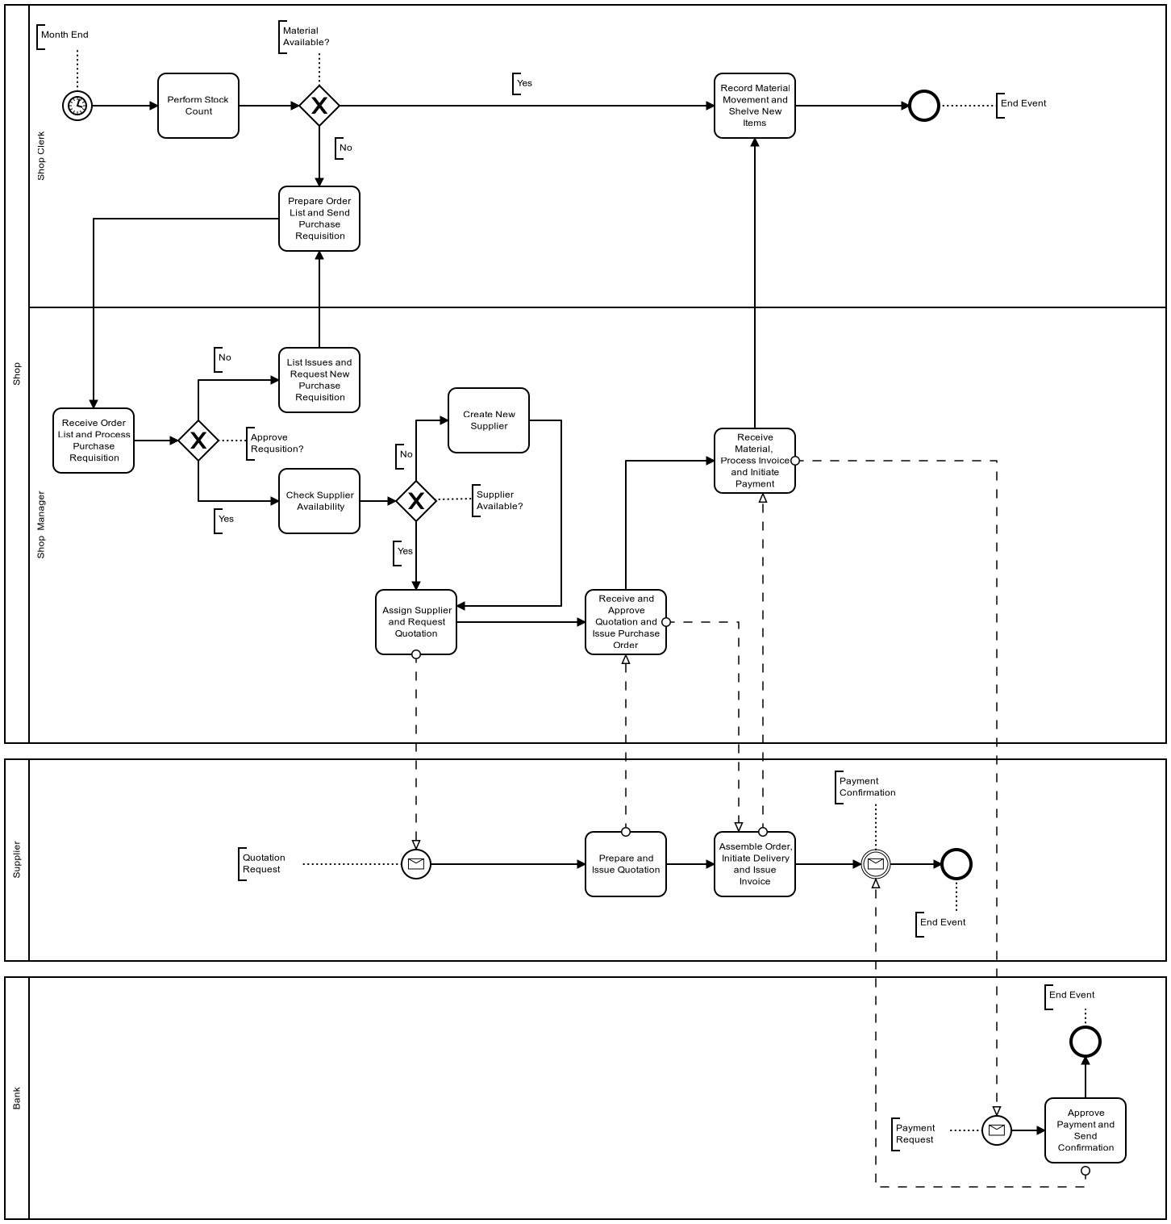

Figure 1: As-Is Product Maintenance & Stock Prediction BPMN Diagram

The current processes that average store owners are currently following. Is demonstrated in Figure 1. The process is initiated when a purchase requisition is created. A quotation will either be requested by the store owner from the supplier. The two will agree on payment terms which differ from store owner to store owner. Once the quotation has been accepted by the store owner, an order is placed for the inventory required for either the month or the next few months. Your smaller stores are more likely to order on a month-to-month basis as it provides them with the following two benefits: not requiring large storage space as well as being able to cover inventory prices based on the profit made in the previous months.

Once the store owner has received the goods, he/she will pack them onto the shelves and only monitor inventory levels by doing a physical stock check at the end of the month. Being cognisant of the types of stores we are dealing with, and the lack of proper investment, investment referring to as technological equipment, capital, and capabilities one can already see the hitches that can arise.

The difficulties of this process include:

* Not being fully aware of how much stock they have on their shelves at any given time.
* Not being able to tell when stock has been stolen.
* Not being able to tell upfront the shelf-life of the inventory resulting in goods going bad on the shelf and store owners disposing of those goods which is a waste of inventory. This could also result in store owners ordering less than they need to prevent goods going bad on their shelves which minimizes their profit potential.
* Store owner’s capital becomes tied up for large purchase order.
* This process does not consider the several of stock levels required for different seasons and/or occasions.

## 4.2. Proposed process

The proposed process will be different from the as-is process in that the process will now be carried out through the MSP instead of manually. Most of the process will not change, with the differences being that product records will be added and managed on the MSP and the stock prediction will now be done by the MSP system. An activity diagram has been included to show how the system would use machine learning to provide its prediction.

To put things into perspective, we can look at an example using UCT’s registration process. Until this year, the UCT registration process was done manually. The nationwide lockdown restrictions because of COVID-19 made it difficult for the university to continue its process in the same way. The process thus had to be moved online. The online registration process was still the same in that students still filled out the same forms and still consulted with the same faculty advisors where necessary. All that changed was the platform on which the process was carried out. The same will be observed in the to-be process that uses the MSP as its new platform. This is shown in the following BPMN where the first steps in the diagram are related to automated tasks.

### 4.2.1. TO-BE Product Maintenance & Stock Prediction Process

### 

Figure 2: To-Be Product Maintenance & Stock Prediction BPMN Diagram

The new process that will occur because of the MSP is demonstrated in Figure 2. As highlighted previously, most of the process has not changed. The following activity diagram depicts how the MSP system will be working in the background to predict the optimum number of products (stock) required while the tasks in the BPMN are being carried out.

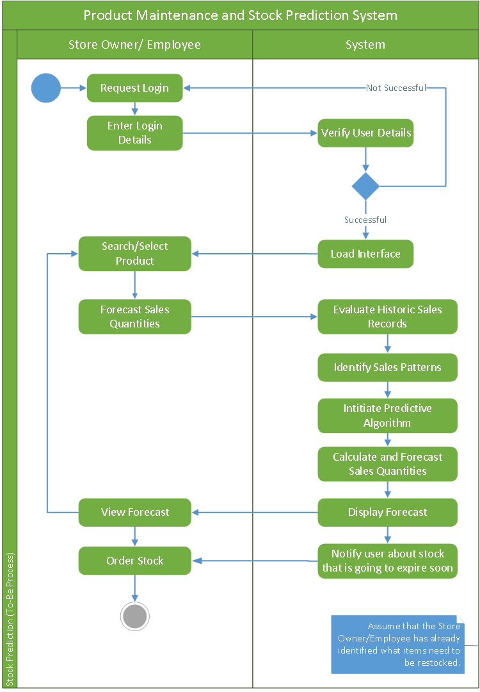

Figure 3: Figure 3: To-Be Product Maintenance & Stock Prediction Activity Diagram

The MSP will solve the given difficulties of the current process by:

* Allowing owners to be fully aware of the exact levels of stock that they have on their shelves.
* If any theft occurs, store owners will be able to tell sooner than month end that there is some stock missing.
* Owners will be able to get quantities of stock that allow for profit maximization.
* This can allow owners to make purchases of stock in batches for their specific needs.
* It enables store owners to have regular reviews of stock. At every review, an order is placed to return stocks to a pre-determined level.
* Better their stock administration process

Business Rules for the maintenance process:

* Business needs to be a small-medium enterprise.
* Business needs to have a Point-of-Sale system in place.
* Business needs to be a retail business.
* The retail business needs to sell food.

# 5. Value Added

## 5.1. Business value added

Store owners will realise the following benefits from using the MSP:

* **More Accurate Stock Prediction:** Having a manual stock management system means that stores like Marcels must check if they need to update their every day or week. According to Jane (2017), manual stock management systems are at a higher risk of inaccuracies. The MSP will reduce, if not eliminate, the risk of human error because its analyses and predictions will be based on figures and statistics.
* **Saves Time**: Manual stock management processes also require more effort from employees. Employees need to keep a consistent track of stock sales and review the system at the end of each business day. The MSP will help to reduce the workload on staff while saving them time because it will perform the prediction part of the process on their behalf. This will also improve business productivity and operative efficiency.
* **Centralised Storage Space:** The MSP will also give store owners a platform to manage their store information relating to their products and where relevant, their suppliers. This information will be stored on a local database.
* **Less Wastage:** Based on the interviews conducted with Rustenburg Pharmacy and Marcels, both participants believe that having wastage or products expiring on shelves is inevitable for any businesses. The use of the MSP can help reduce the number of items that are wasted even if it is inevitable for some items to still be wasted.
* **Optimised Sales:** The use of the MSP will help store owners optimise their sales which will result in less wastage of stock. Store owners have limited storage and floor space to keep their inventory so they must turn over stock as often as possible to keep up with consumer demand. The MSP’s algorithm will be trained to predict the required quantities of stock to optimum levels. This means that if the MSP predicts that 20 loaves should kept in storage, at least 16 or more loaves should be sold. This will reduce the number of units going back into storage and expiring on shelves. The MSP algorithm will also be trained to consider seasonal patterns and consumer preferences. This means that certain items like chocolates will have higher predicted quantities around times of the year like Mothers’ Day or Valentine’s Day.
* **Optimise Available Resources:** Store owners have limited storage and floor space to keep their inventory. Cog3nt’s aim for the MSP is to have it become a tool that helps store owners maximise the resources they have. If sales are optimised and wastage of stock is reduced, business profits/ revenues will be higher.

Cog3nt will also realise the following benefits:

* Cog3nt will expand their product line which will bring the company closer to achieving its goal of providing businesses with automotive solutions to their problems.
* Cog3nt will also benefit from making a positive contribution to its industry by helping its clients make certain aspects of their businesses better.

# 6. Challenges

In developing our application, have been able to be cognisant of the following challenges and have found ways to mitigate those challenges found in the table below.

|  |  |
| --- | --- |
| **Challenges** | **Mitigation strategy** |
| Accessibility: the type of store owners we have aimed to create this store for may struggle to have access to the investments (i.e., computers, coverage and data/Wi-Fi) to be able to make use of the application. | We have decided to build this system specifically for store owners that already have technological equipment in place to create actual value for them. |
| Literacy: The concept of machine learning can be difficult to understand and overwhelming for people who are not familiar with it. | To ensure that store owners can make use of the system, we will as a team ensure that the application is as intuitive as possible as well as add extra help features. |
| Affordability: a machine learning application can be expensive for the market that we are dealing with. | The application will be much cheaper to use than the traditional ERP software that businesses use. |

Part 2: Innovation

# New Technologies

The MSP is a web application that leverages machine learning techniques to optimally aid a business aid its needs. The development of the web application will require engagement with software development tools, machine learning software development frameworks, and developing machine learning models. For a smooth development experience, we will also be employing a project management and source/version control collaboration tool, as is best practice for efficient software development. A brief overview of these technologies and frameworks is provided below.

### 7.1. ML.NET

Figure 4: ML.NET

Microsoft created an open-source, cross-platform Machine Learning (ML) framework to cater for dot net developers called ML.NET. ML.NET is functional on Windows, Linux and MacOS using .Net Core, it also runs on Windows using the .Net Framework. ML.NET enables dot net developers to create custom ML models without a need for machine learning and data science expertise. The technology allows dot net developers to make use of familiar tools (Visual Studio, VS Code), languages (C#), and their existing skills to incorporate customised Artificial Intelligence into their applications. Examples of the common cases ML.NET is used for are*: Sentiment Analysis, Object Detection, Sales forecasting, Price Predictions, Image Classification, Customers Segmentation and Product Recommendation.* (Microsoft, n.d.)

ML.NET is 100 percent free and functions with almost all types of .Net applications (Microsoft, n.d.). These include services, microservices, desktop apps, and Azure Functions, and more relevant to this project, it supports web applications. Microsoft provides detailed ML.Net tutorials and documentation to aid us with our learning process, and our project sponsor has also indicated his willingness to offer any technical support as the need arises, during development. ML.Net is also easy to add to any .Net project via the Microsoft.ML NuGet Package. The team will be using the ML.Net Model Builder (available only on Windows) as it supports AutoML, a feature that assesses varying ML algorithms and settings automatically to aid us attain one that is most appropriate for our scenario.

### 7.2. Azure DevOps and Git

Figure 5: Azure DevOps and Git

Azure DevOps is Microsoft’s development collaboration tool that allows collaborators to plan better, collaborate seamlessly and develop projects faster. Azure DevOps integrates with the Visual Studio Integrated Development Environment (IDE), which the team is most familiar with and has most experience utilising. The platform caters for holistic project management, enabling task delegation among collaborators, status tracking and setting timelines. As students Microsoft grants us the use of Azure DevOps and its host of services at no cost, and additionally they grant us US$100 to use within 12 months on their paid DevOps services.

Version control is a critical component of software development, version control is the protective layer for source code against any unplanned consequences, whether technical or human error. When a developer is coding new components and another collaborator is fixing a bug (unrelated) and changing the code, the source file may contain several changes. These changes can be tracked, and their contributors can be traced, and can resolve any conflicts from the co-current code modifications. Due to the global Covid-19 pandemic, the team is working in remote locations and is therefore required to work in an environment that can be accessed by all. The team will use Git as its distributed version control tool as it is already integrated into the Azure DevOps platform that we will be using. Git will allow us to track & trace any modifications during the development lifecycle while also allowing us to integrate our source code and project management easily.

A typical software development application life cycle consists of the building, maintenance, and constant updating of the end-user business application is illustrated below.

Figure 6: Azure DevOps Application Development WorkFlow

The diagram below illustrates an application life cycle that incorporates Artificial Intelligence (an ML.NET model in this instance) into the application, lengthening the typical life cycle. This is typically called the “*Machine Learning Model Life Cycle”.*

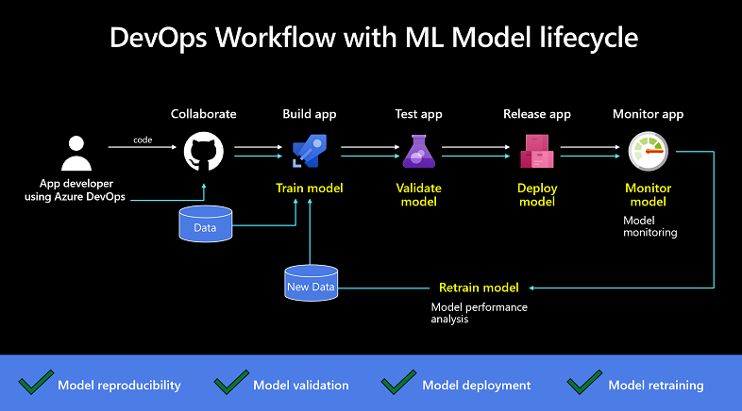

Figure 7: Azure DevOps Application Development WorkFlow – with Machine Learning Model Lifecycle

The process for tracking, versioning, auditing, certification, and repeated use of all the assets in the ML model life cycle needs to be automated pre deployment into production, including the end-user application life cycle (De la Torre, 2019). In the undertaking of this project, we will be using Azure DevOps to generate, train, test, evaluate and automatically the ML model as well as the end user application’s Continuous Integration (CI) and Continuous Delivery (CD) pipelines.

In a similar way that code modifications trigger build and application tests for CI and application deployment in CD pipelines, any changes to the training code/data will trigger a new ML model to be trained by the Azure DevOps CI build pipeline. The model file will be unit tested, quality validated and then deployed into the end-user application before the CD release pipeline deploys it into the application (De la Torre, 2019).

# New Way of doing things

The approach to this system development project will be through the Agile Project Management Framework, Scrum Methodology. And due to the ongoing Covid-19 pandemic, the need for Remote Learning and interaction is still necessary. Therefore, we will be employing a host of digital collaboration technologies to aid us in usefully delivering this project. What follows is a breakdown of what *Scrum* is and what it means to us as well as a brief overview of the platforms we will engage with for our team collaboration and communication, namely, *WhatsApp, Miro, Microsoft Teams, and Microsoft Outlook.*

### 8.1. Scrum Methodology

Scrum is an agile methodology for guiding teams through the iterative and gradual implementation of a project. The emphasis is on the use of an analytical approach that enables teams to adapt quickly, accurately, and successfully to change (Sliger, 2011). In previous years, when it came to the software development life cycle, the team still followed the standard Waterfall approach.

The standard waterfall approach is used to correct requirements to manage time and expense, while the scrum methodology is used to fix requirements to control time and cost. As a result, this is a novel approach for us, and you can see the distinctions in the way this technique fosters teamwork. The client or stakeholders' presence is crucial in the process, since Scrum relies heavily on cooperation between the company and the customer, stakeholders, or customer representative to deliver the best result. Time boxes, collaborative ceremonies such as meetings, a prioritized product backlog, and regular feedback cycles are used to do this (Sliger, 2011).

There are only three positions in Scrum, and we have assigned each task to members of the team. Our scrum master is Kimberley Mugadza, and she serves as the team's spokesperson, removing obstacles, promoting team communication, mediating team conflicts, and negotiating with external stakeholders. Second, Matete Kopano Lebakeng is our product owner. She is responsible for presenting the vision to the team, as well as identifying and prioritizing backlog items. She collaborates with the team on a regular basis as the product owner, answering questions and providing product guidance.

Finally, the scrum team is comprised of Khanya Ngxabani and Maphoro Ramotebele; they are self-organizing and accountable for the project's delivery; they own the estimates, contribute to tasks, and communicate everyday status to one another and the rest of the team during the daily scrum. Scrum is an agile project management framework that enables teams to execute projects iteratively and incrementally while continuously inspecting and adapting their processes (Sliger, 2011).

### 8.2. Remote Learning

#### 8.2.1. WhatsApp

Remote learning necessitates the need for virtual interaction. This will require the use of digital communication and collaboration tools. We will be using *WhatsApp* as a communication medium to keep all team members updated on what we are doing and any quick updates as they arise. WhatsApp is also useful for conducting daily scrum meetings as well as keeping reminders about team meetings and deadlines. Clarification un misunderstandings and team members approving each other’s work can be communicated on this platform which also ensures that all team members are kept in the loop without necessarily having to meet them at a specific time, as they can read the message whenever they can.

#### 8.2.2. Microsoft Teams & Miro

Remote learning also has the consequence of not physically meeting the collaborators you are working with, therefore the ability to host meetings on *Microsoft Teams* is paramount because of its video and audio call functionalities. It also enables us to simultaneously collaborate on documentation and safely store it within the platform. Microsoft Teams also integrates third party applications into its platform, allowing us to integrate our collaboration tool Miro for ease of access to features such as our task board for team member’s perusal. We will also be hosting our meetings with the sponsor and lectures through Microsoft Team.

#### 8.2.3. Microsoft Outlook

Microsoft Outlook is also a critical technology we are using in this remote environment as it allows us to integrate email communication, organize meeting appointments and automate invitations or reminders for Microsoft Teams meetings, which for us is the most useful feature.

# Technical challenges

When developing an application like MSP the team needs to be cognisant of any challenges that may arise. We have tabulated the possible challenges that may arise during the development of this project below as well as how we plan to mitigate those challenges.

|  |  |  |
| --- | --- | --- |
|  | **Challenge** | **Mitigation Strategy** |
| 1. | New software languages: ASP.NET Core is a new language required for the development team to use to create this application which can be a challenge to learn. | Have the teammates complete the ASP.NET Core workshops offered by the course convenor of INF4027W. |
| 2. | Getting the application to adjust to different screen sizes and operate on different web browsers. | The team will use Visual Studio which automatically adjusts for different screen sizes and devices. |
| 3. | Every store owner using the application needs to be certain that their products and data will be protected. The team security programming skills may not be up to par with what the end user needs. | We will be developing the application using high-level programming languages with built-in security features.  Our sprints will also include a code review which will test the secureness of the application. |
| 4. | MSP requires a safe and secure database; owners need to be sure that data will always be available and accurate. | The team will be hosting their application onto Azure cloud services to ensure that their records are secure and backed up. Microsoft Azure’s data storage service offers secure and scalable cloud storage for both, structured and unstructured data.  Using Azure Storage, the data security experts can ensure safe integration of the on-premises data supplied by the store owners with the cloud data (Team, 2021). |
| 5. | Integrating the prediction (machine learning and Artificial Intelligence) components with the rest of the application | We will be using a platform (Azure) that has AI embedded services will help the team minimize the load of integrating. |

# Application Architecture

As a result of hosting the application on Azure services, the solution allows us to make use of its computing facilities. We will be using an Event-driven serverless architecture hosted by Azure services. Event-driven architecture (EDA) is based on decoupled systems that run-in response to events. An event-driven architecture uses events to trigger and communicate between decoupled services; this feature falls part of the Azure app services.

The serverless model is also quickly scalable, enabling quick updates and deployment and it is stateless which is seamless for the SME’s that we will be creating this system for. The type of serverless architecture we will be using is Backend-as-a-Service (BaaS). It Utilizes services from a third party (Microsoft Azure Functions), such as application management, database management, and cloud storage.

Below is an image of the serverless architecture. The diagram demonstrates how the application will be built by the development team by collaborating on Azure DevOps whilst using Visual Studio. The application will then be deployed onto Azure app service which will be hosting the application as well as assisting with the migration, scalability, and security of the database. Finally, the application will be used on the web (internet) by the final consumer.

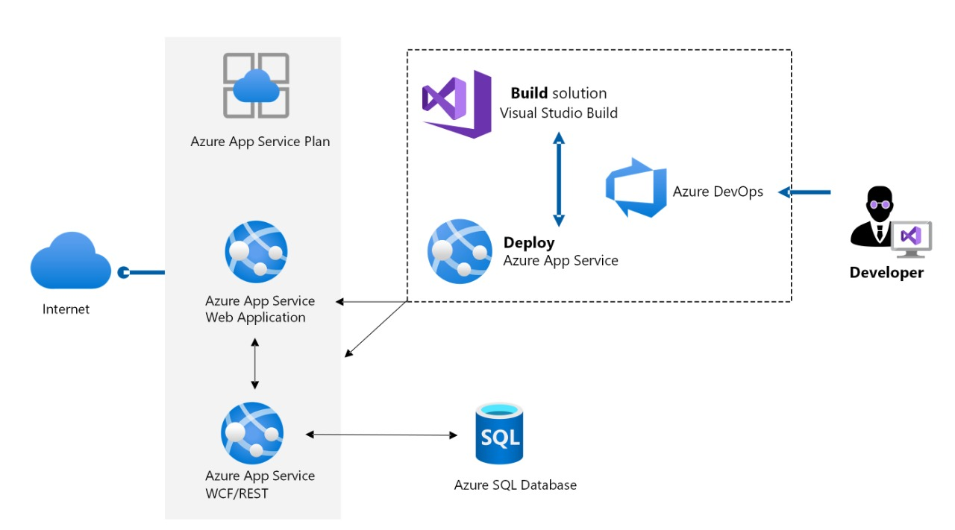

Figure 8: Application Architecture

This designed architecture enables the customer to make use of the dynamic scalability and availability. By using the Azure database migration services, store owners, on premises database can be migrated to Azure SQL.

### 10.1. Migration process:

Figure 9: Migration Process

Characteristics:

* The product inventory as well as the prices will then be pulled from the Azure database when needed.
* Customers will connect to the product catalogue through the front-end web application.
* The load balancer will automatically scale during increased or decreased periods of traffic to improve the web application run-time i.e., availability.

Azure services that will be used:

* Azure app service: this is an HTTP-based service that enables the hosting of web applications as well as REST API’s.
* Azure SQL database: this is relational database service built for the cloud that is highly available.
* Azure DevOps: this is what the team is using to collaborate on the code, it will also assist with the deployment of the application.
* Azure Database migration services: This component will allow us to migrate from our databases to Azure as efficiently as possible.

**Advantages of this architecture:**

* Run and scale web and API applications on the platform of your choice—in a high-productivity, fully managed environment.
* Scale on demand.
* Improve team agility and performance by using a fully managed platform to build, deploy, and operate applications.
* Reduce the time spent on tasks that are non-core to the business by freeing developers from infrastructure provisioning and management.
* Minimize risk through security management provided by Azure.
* Save on major technological costs and only pay for specific services that are used at low rates.

**Disadvantages of this architecture:**

* Ongoing cost for EC2 servers and load balancers.
* Lack of local testing options: local testing requires duplicating all the serverless limitations locally.

# System Scope

The following package diagram shows the layered architecture of the MSP web application. The front end represents the interface which the user will use to interact with the system. The front end will be an ASP.Net Core (Model-View-Controller) web application. The system will be authenticated with Logins and User Roles. Depending on the number of users who will have access to the MSP within a store, some information may need to be authenticated so that only authorised users can access the information. The front end also processes user requests to the system via the controllers. For the product maintenance aspect of the MSP, users can keep a record of all their store products using CRUD. Where applicable, users can also keep a record of their supplier(s) on the MSP.

The back end of this application uses information provided from datasets to train the model and create an adaptive stock predictive algorithm. The data for products that will be stored in this system will come from the spreadsheet provided to us by our sponsor; this dataset has all the information with about the various products that will be stored in the database of our application, but the data stored on the MSP will be stored in a local SQL database. Generating our own the data is out of scope for this project because the data that will be used to create the MSP has been provided to us by Cog3nt.

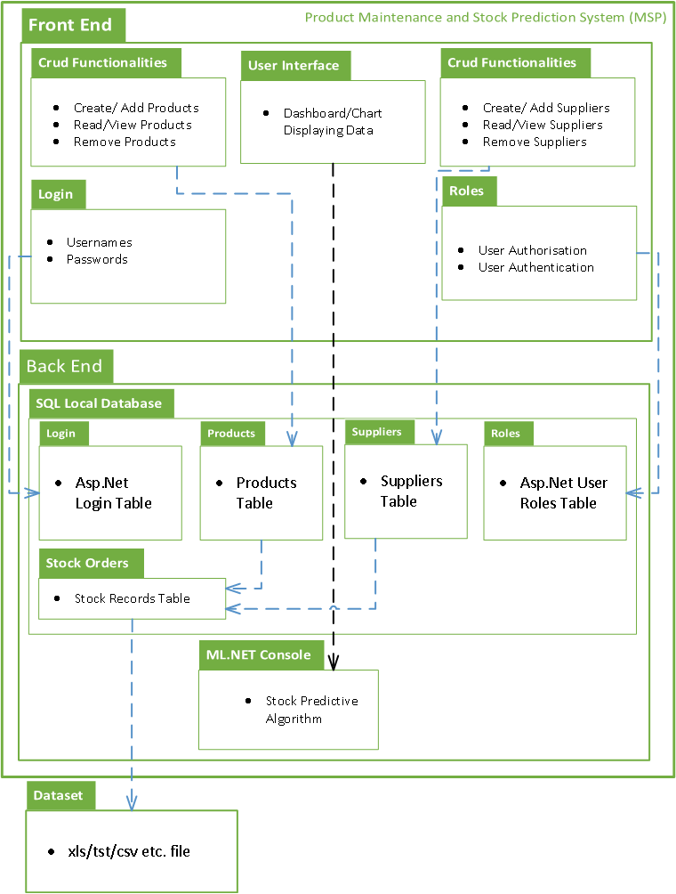

Figure 10: MSP Package Diagram

# ER Diagram

This Entity Relationship Diagram (ERD) shows the different relationships of the tables inside the MSP Local SQL Database. The first half shows how the relationships between the users in the system will work. The second half shows how the relationships between the classes (information relevant to the MSP stock prediction aspect) will work. The products and supplier classes store information related to the products kept in the store. In the dataset, all the information is kept in one file, and we have noticed some duplication of columns and information. We have decided to separate this information and design our database scheme in 3rd Normal Form to reduce the data redundancy we have observed. Having our database schema designed with this approach will also prevent any data anomalies, ensure referential integrity, and simplify data management in the MSP.

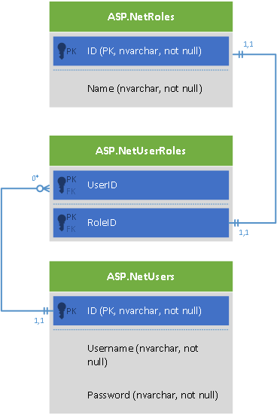

Figure 11: MSP ERD Diagram for User Relationships

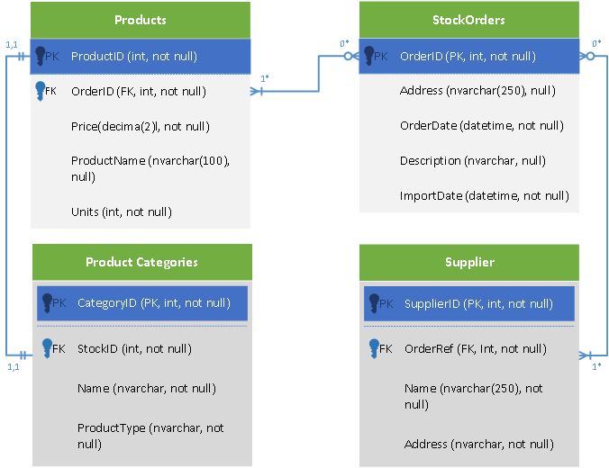

Figure 12: MSP ERD Diagram for Dataset entities

# Class Diagram

Lastly, we have the class diagram. Like the package diagram, the class diagram shows how the front and back end of the system will work together. The back end is an ASP.NET Core Console Application while the front end is an ASP.NET Web Application. These are separate projects that will be combined in the same solution to create the MSP. The data collected from the ML.NET analysis will be saved locally in a public sealed class called DataViewSchema which will be part of the backend. Public sealed classes are stored in the Assemblies of a solution. Assemblies in Visual studio are implemented as .exe or .dll which are not stored in the project’s database.

The backend shows how the .NET Console App will process the information from the dataset using methods. These methods are all in the “Time Series/Regression” Class. The type of algorithm that will be used (Time Series or Regression) depends on which model Visual Studio’s ML.NET library identifies to be the most accurate. Regardless of the model that will be used, the concept of what the methods will be doing will stay the same. The StockOrder class stores the recorded stock order and product sales histories that the backend of the MSP will use to learn and adapt.

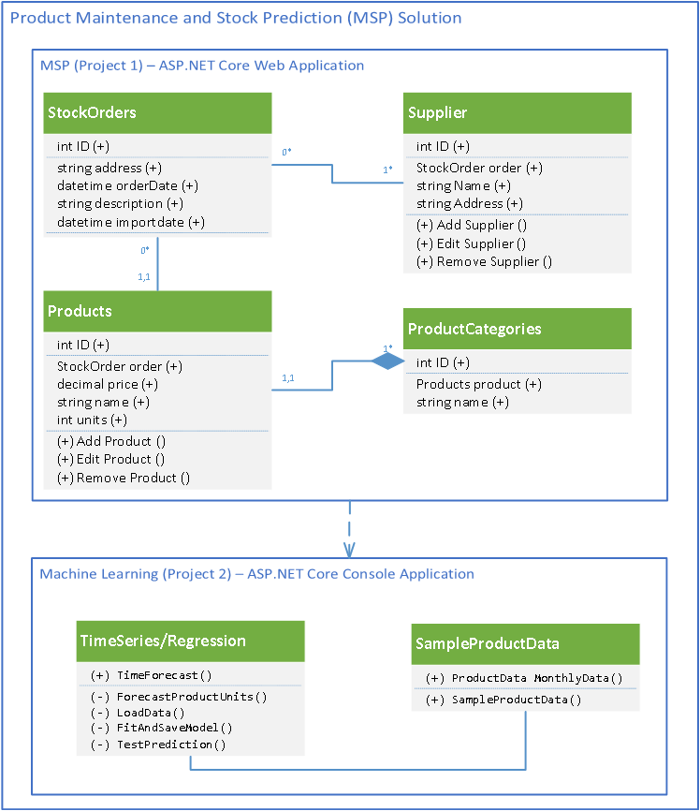

Figure 13: MSP Class Diagram

# Conclusion

This document has given a detailed analysis into the business problem that was identified by Cog3nt which has resulted in this Systems Development Project. Now that the analysis phase is complete, the team will now focus on developing the first iteration of the MSP. The team will begin by completing the user stories related to the product maintenance aspect of this system (I.e., CRUD, roles, login and basic UI for the homepage) for the first the first iteration. This will be achieved by working closely with our user story map and planning the deliverable for our first release in sprints.

# References

Cog3nt.com. (n.d.). <https://www.cog3nt.com/>

Cousineau, M. (2019). *How to improve maintenance inventory management.* Fiix Software. <https://www.fiixsoftware.com/blog/8-ways-to-control-inventory-related-costs-with-maintenance-assistant-cmms-2/>

Intelligent Automation. (n.d.). *Intelligent Automation – Combine the power of RPA and AI to empower rapid end-to-end business process automation.* [*https://www.automationanywhere.com/rpa/intelligent-automation*](https://www.automationanywhere.com/rpa/intelligent-automation)

De La Torre, C. (2019, May 28). ML.NET Model Lifecycle with Azure DevOps CI/CD pipelines. *Microsoft DevBlogs.*

<https://devblogs.microsoft.com/cesardelatorre/ml-net-model-lifecycle-with-azure-devops-ci-cd-pipelines/>

Figure 8: Source: <https://docs.microsoft.com/en-us/dotnet/machine-learning/how-does-mldotnet-work>

Goyal, V. (2020). *Is Cost-Effective Automation On The Cards For Small And Medium-Sized Enterprises?* INC42. <https://inc42.com/resources/is-cost-effective-automation-on-the-cards-for-small-and-medium-sized-enterprises/>

Hughes, E. (2020). *Why is Stock Control Important?* Pandle. [Why Is Stock Control Important? - Pandle](https://www.pandle.com/blog/2020/10/28/why-is-stock-control-important/)

Jane, M. (2017). *Difficulties in Using a Manual Inventory System.* BizFluent. <https://bizfluent.com/info-8007357-difficulties-using-manual-inventory-system.html>

Lister, J. (2017). *The Advantages of Manual Inventory Systems.* BizFluent. [Business Rules for an Inventory System (bizfluent.com)](https://bizfluent.com/info-7920237-business-rules-inventory-system.html)

Microsoft. (n.d.). *What is ML.NET?* Microsoft. <https://dotnet.microsoft.com/learn/ml-dotnet/what-is-mldotnet>

Oxford Learner’s Dictionaries. (n.d.). *Define – Machine Learning.* <https://www.oxfordlearnersdictionaries.com/definition/english/machine-learning#:~:text=%5Buncountable%5D,as%20they%20encounter%20additional%20data>.

Zoho Inventory. (n.d.). *What is Inventory Forecasting? | Definition Methods & Formula.* [*https://www.zoho.com/inventory/guides/inventory-forecasting.html#:~:text=Inventory%20forecasting%20is%20a%20method,revenue%20and%20decrease%20unnecessary%20costs*](https://www.zoho.com/inventory/guides/inventory-forecasting.html#:~:text=Inventory%20forecasting%20is%20a%20method,revenue%20and%20decrease%20unnecessary%20costs)*.*

*Infoentrepreneurs.org. 2021. Stock control and inventory. [online] Available at: <https://www.infoentrepreneurs.org/en/guides/stock-control-and-inventory/> [Accessed 4 May 2021].*

*Thakkar, M. (2021). 10 Challenges Every Software Product Developer Faces | Synoptek. Synoptek. Retrieved 9 May 2021, from* [*https://synoptek.com/insights/it-blogs/10-challenges-every-software-product-developer-faces/*](https://synoptek.com/insights/it-blogs/10-challenges-every-software-product-developer-faces/)

*Team, V. (2021). An Overview of Microsoft Azure Services. VictorOps. Retrieved 9 May 2021, from* [*https://victorops.com/blog/microsoft-azure-services-overview*](https://victorops.com/blog/microsoft-azure-services-overview)*.*

*What is Software as a Service (SaaS): A Beginner's Guide. Salesforce.com. (2021). Retrieved 9 May 2021, from* [*https://www.salesforce.com/in/saas/*](https://www.salesforce.com/in/saas/)*.*

Sliger, M. (2011). *Agile project management with Scrum*. Paper presented at PMI® Global Congress 2011—North America, Dallas, TX. Newtown Square, PA: Project Management Institute. Retrieved 10 May 2021, from <https://www.pmi.org/learning/library/agile-project-management-scrum-6269>